Zepic External Documentation  
Date: December 16, 2013  
Brandon Hewlett & Vincent Nguyen

a.



b. Table of Content

1. Homepage
2. Upload
3. View Profile
4. Edit Blog
5. Edit Profile
6. Logout

c. The core functionality of our website is to provide users with a blog site where they can express their ideas and share them with peers. It allows other users to comment and respond aswell.

d.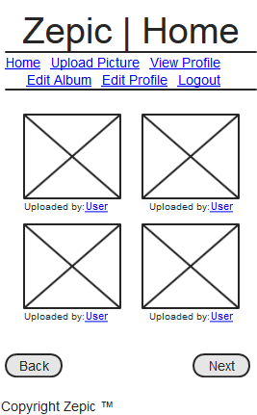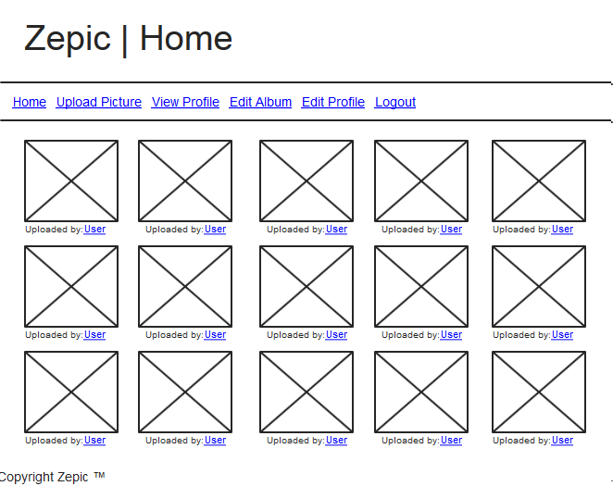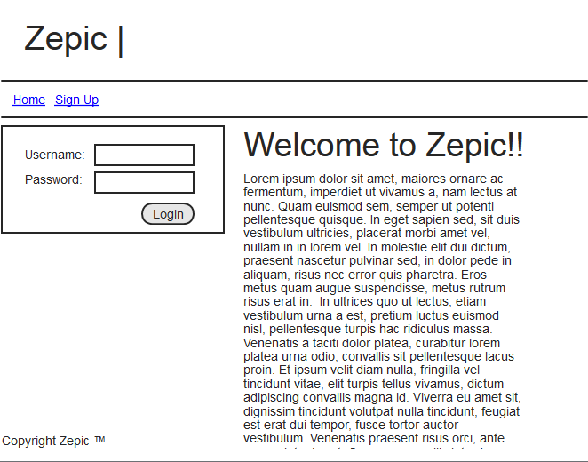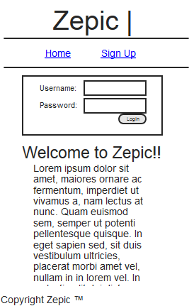

f. – Make a picture upload button to go along with the message  
-Add a friend/subscription button  
-Add video sharing and widgets  
-Blog messenger